**Portfolio build out**

HYBRID IAM ARCHITECTURE FLOW  
  
On-Prem Active Directory  
 ↓  
Entra Connect Sync Server  
 ↓  
Microsoft Entra ID (Cloud)  
 ↓  
Pass-through Authentication

Phase 1, Step 1

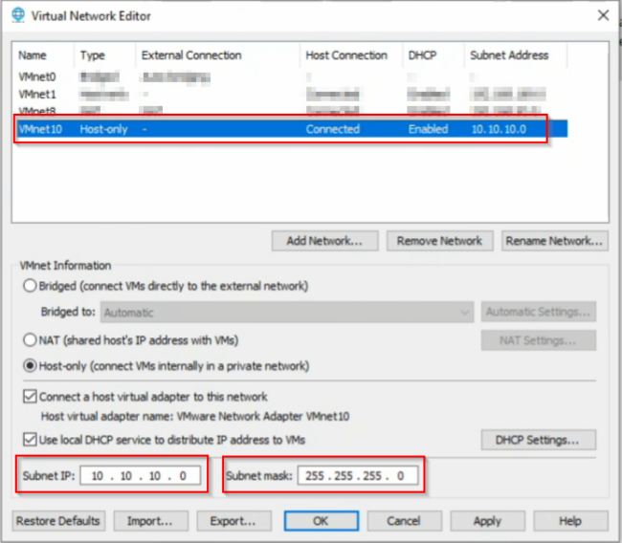Setting up the foundation of our infrastructure by creating VMnet10 Host-only network on the 10.10.10.0/24 address range

**Static IP plan:**

DC01: 10.10.10.10 ADFS01: 10.10.10.20

AADCONNECT01: 10.10.10.30

WIN11-CLIENT: DHCP or 10.10.10.100 DNS for all VMs: 10.10.10.10

DNS:

internal domain porsche.local federation name: fs.porsche.local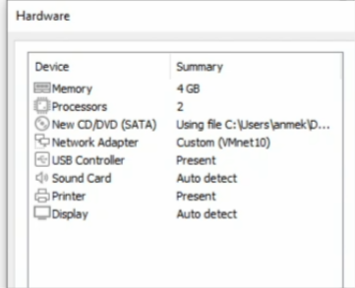

Phase 1, Step 2

Create the VMs with these minimum specs

**DC01 (Server):**

2 vCPU, 4–6 GB RAM, 60 GB disk

**ADFS01 (Server):**

2 vCPU, 4–6 GB RAM, 60 GB disk

**AADCONNECT01 (Server):**

2 vCPU, 6–8 GB RAM, 80 GB disk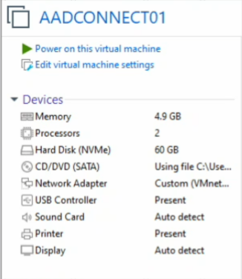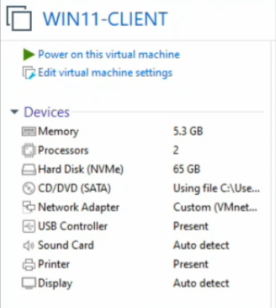

**WIN11-CLIENT:**

2 vCPU, 6–8 GB RAM, 80 GB disk

**Phase 2 - On-premActive Directory**

**Step 3, Building out DC01 as Domain Controller (AD DS + DNS)**

We started off by installing Windows Server 2016 Standard (Desktop Experience) and setting up our Administrator account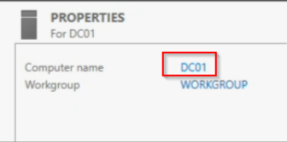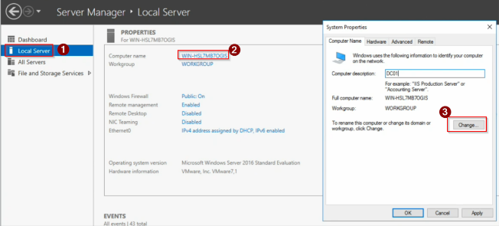

Set up of our DC is as follows:

1. Rename the server to DC01

2. Set a static IP + DNS pointing to itself. The fixed IP address is so that clients, servers and cloud services can reliably find and locate DNS and authentication services. Changing IPs can break authentication and directory services. We point DNS to itself so that the domain

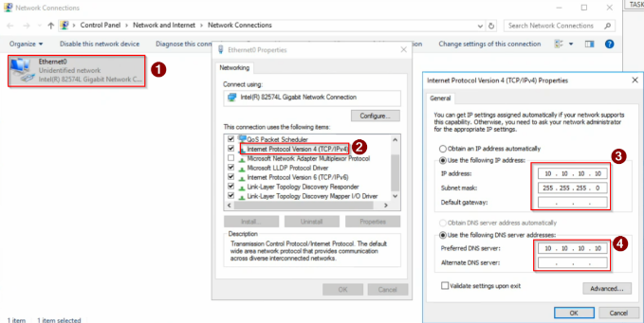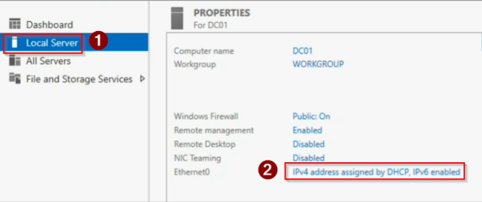services can function properly.

We can quickly verify our settings with PowerShell: ipconfig /all

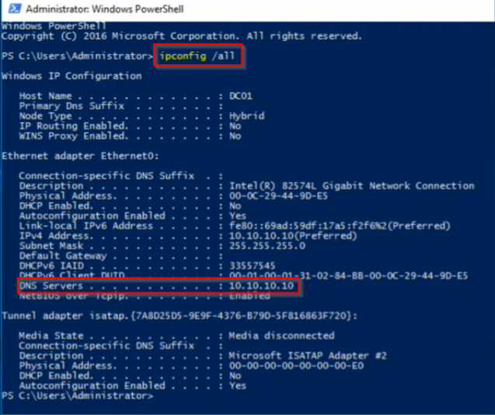

**InstallAD DS + DNS roles**

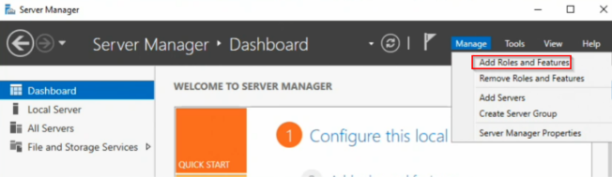1. Adding the AD DS and DNS roles

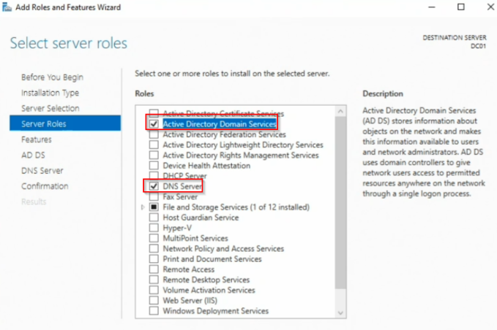

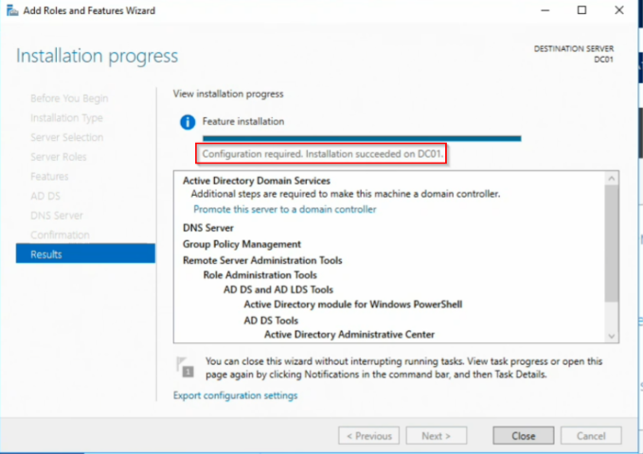Successful installation:

We deployed Active Directory Domain Services and DNS together because AD requires DNS to function.

**Promote DC01 to a Domain Controller**

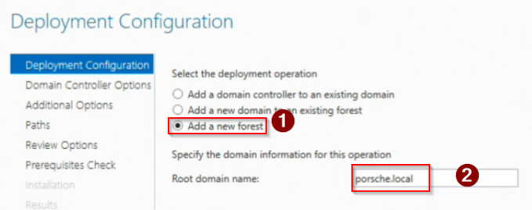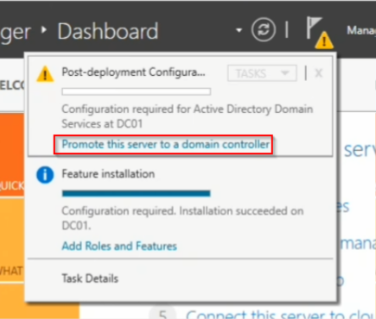1. Promote to domain controller. Within the domain controller configuration, we establish a new forest which will define the security boundary and trust model for AD. In order to have a hybrid integration with Entra ID, we need to have this forest establish a clean, isolated environment. In short, the AD forest represents the core identity boundary for the org.

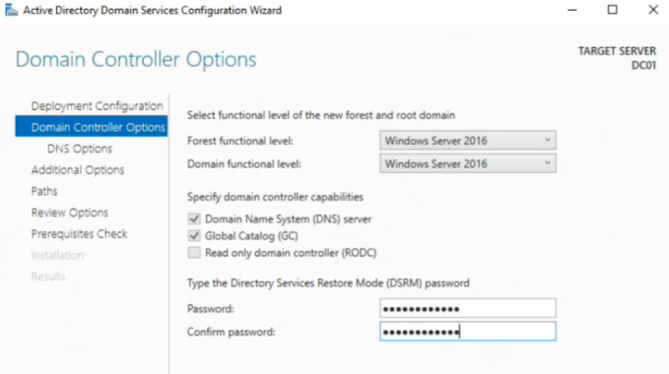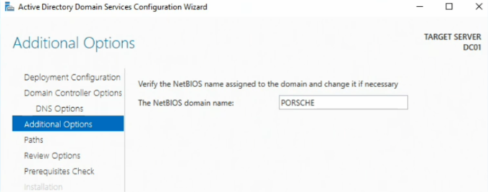

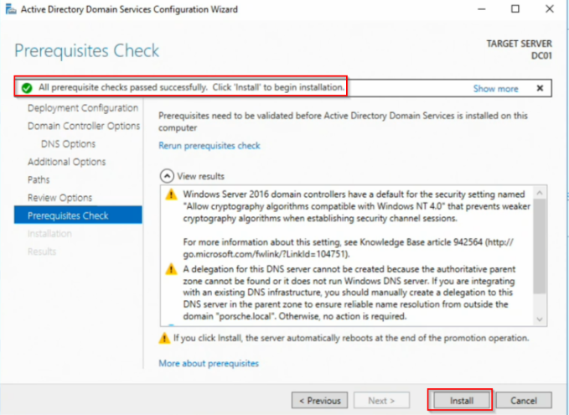

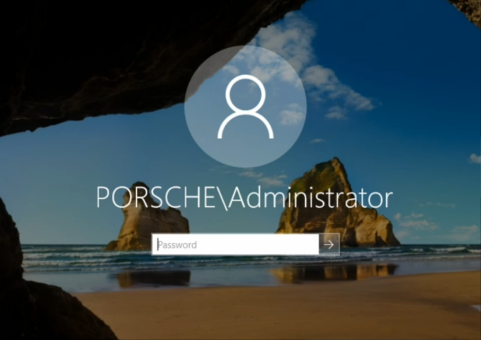

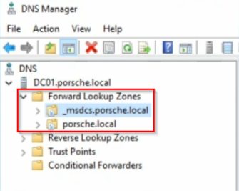We confirm that porsche.local and _msdcs.porsche.local exist in the DNS manager as well as ADWS, DNS, and NTDS are up and running. The zones in DNS manager are critical for clients, servers, and cloud connectors to locate domain controllers for authentication and directory operations.

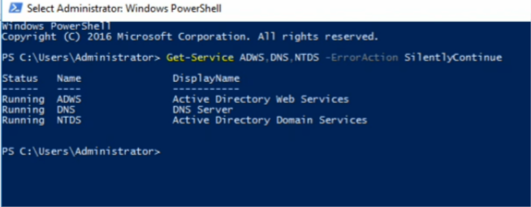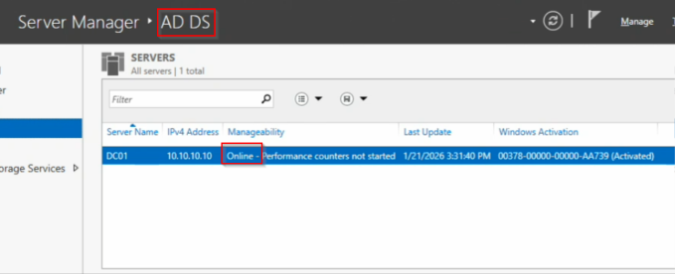

More confirmation that AD DS is up and running

**Create OUs + groups**

1. Here we will create our organizational units and groups. OUs enable structured administration and controlled synchronization to Entra ID. Within our Groups OU, we create groups with RBAC. We assign access to groups instead of individual users to improve scalability and auditability -- Group-based RBAC is the foundation of scalable access management.

2. Additionally, we created pilot users so that we can safely test identity features such as synchronization, SSO, MFA and SSPR before wider rollout. Pilot users reduce risk when implementing identity changes.

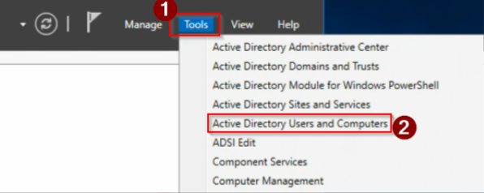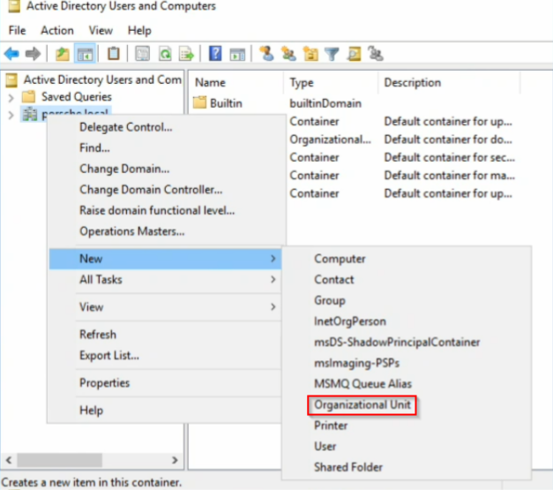

Created: Groups, Servers, Workstations, Service Accounts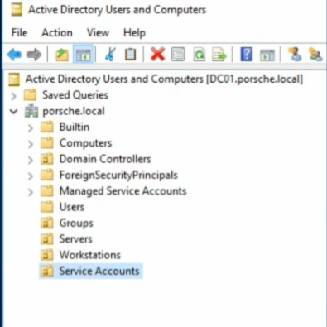

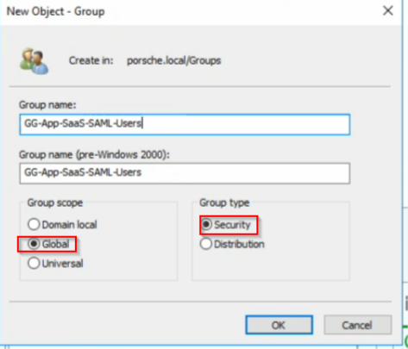Within the Groups OU we create various security groups with GG naming convention (global group)

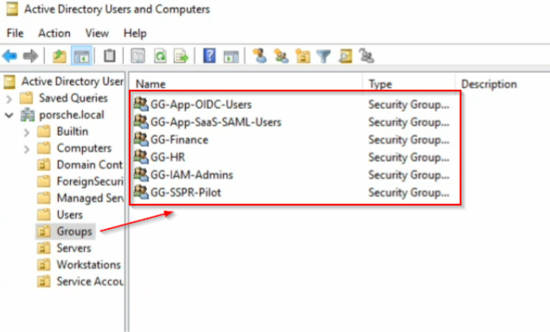

Now inside the Users OU we will create the following test users and assign them to security groups:

Alice HR (member of GG-HR, GG-SSPR-Pilot)

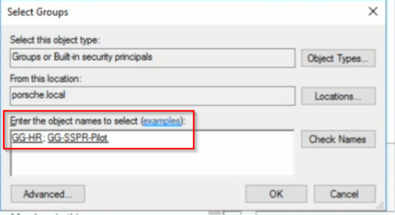

Bob Finance (member of GG-Finance)

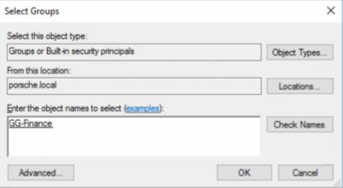

IAm Admin (member of GG-IAM-Admins)

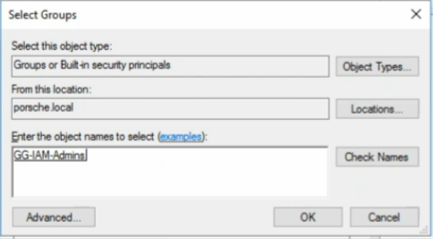

**Step 4: Join servers + client to the domain**

1. For ADFS01, AADCONNECT01, and WIN11-CLIENT we will be setting the DNS to point to the domain controller

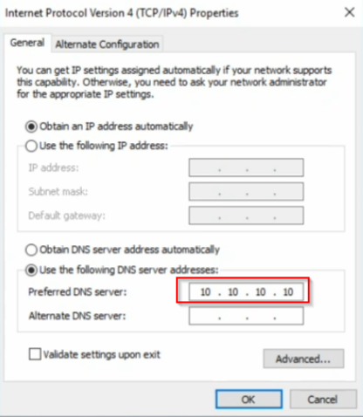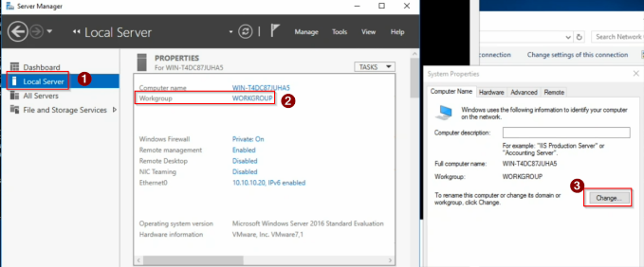ADFS01:

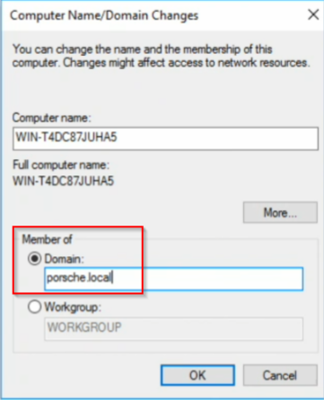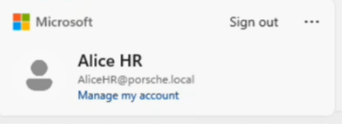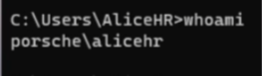

Repeat same steps for AADCONNECT01

WIN11-CLIENT:

**Move computer objects into the correct OUs (important for organization)**

When we keep our objects in OUs, we support scoped sync to Entra ID, targeted policies, and cleaner operations and auditing.

1. Moving ADFS01 and AADCONNECT01 to the servers OU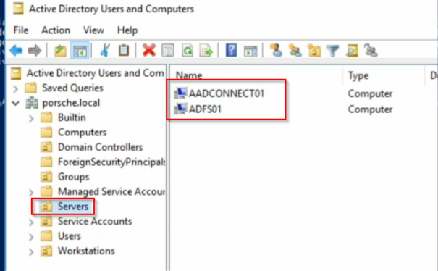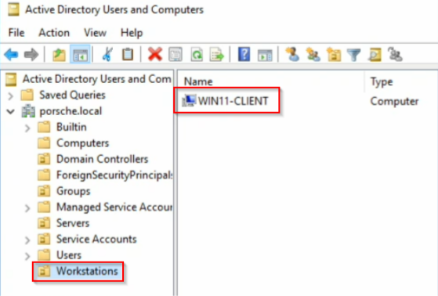

2. Moving WIN11-CLIENT to Workstations OU

**Create "Domain Join" admin account**

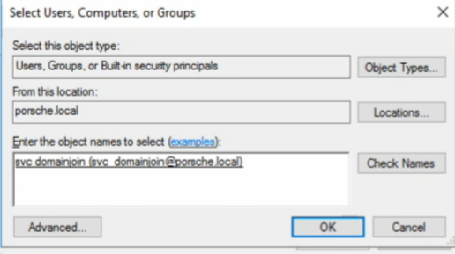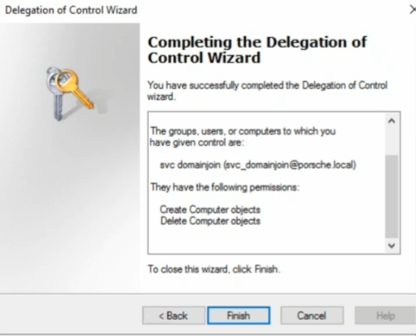

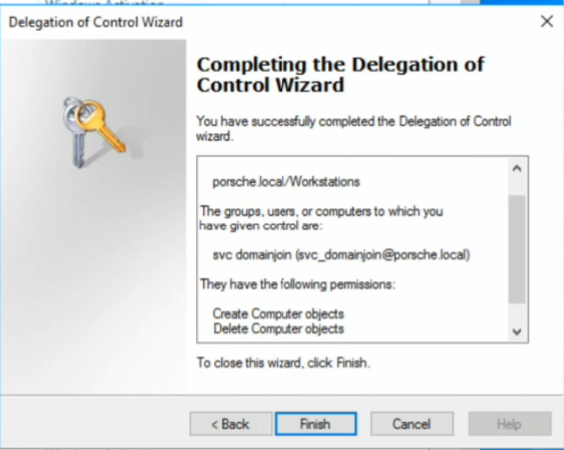

**Phase 3: Certificates (AD CS +AD FS Certs)**

In this portion we will:

1. Install an internal Certificate Authority (CA) on DC01 2. Issue an SSL certificate for AD FS (fs.porsche.local)

3. Export the cert (with private key) and install it on ADFS01

**InstallAD CS on DC01 (Enterprise Root CA)**

AD FS requires trusted certificates for HTTPS. We're setting up an internal CA to issue and manage certificates without the need for buying public certs.

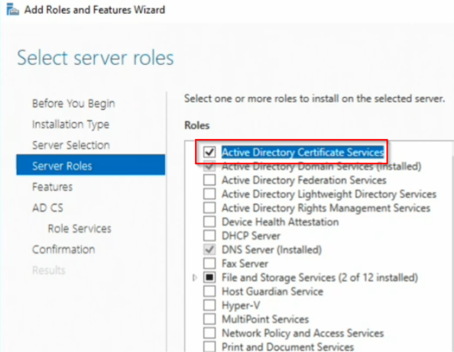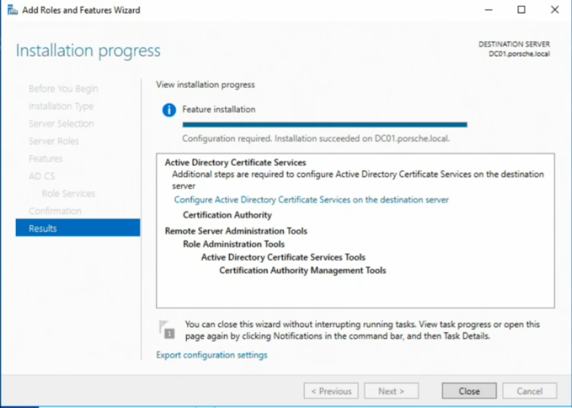

**ConfiguringAD CS**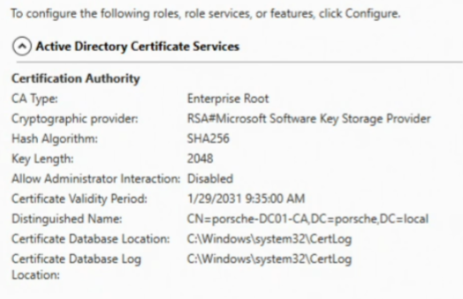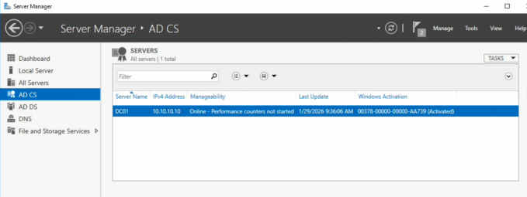

An enterprise Root CA integrated with Active Directory so domain machines can automatically trust certs and request them using templates - this mirrors real enterprise PKI.

Verifying the CA is trusted on ADFS01. If clients/servers don't trust the CA, they will see certificate warnings and federation can fail.

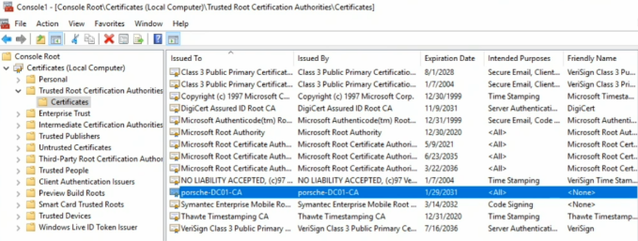

**Create the DNS A record on DC01**

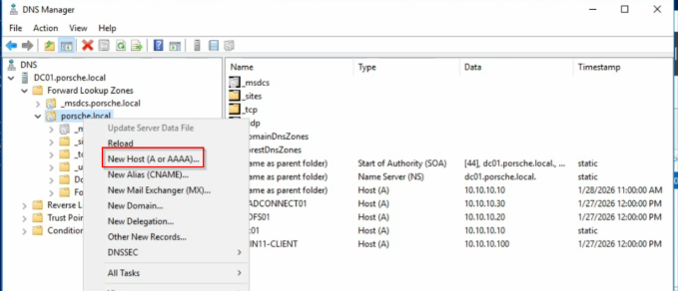We are creating this DNS A record so that clients and servers can resolve fs.porsche.local to reach the AD FS web service over HTTPS

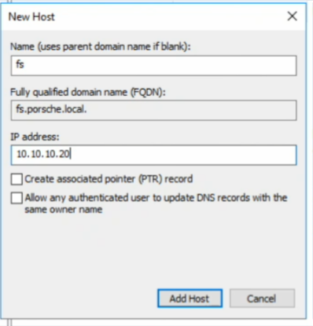

**Requesting the cert on ADFS01**

In order to request the cert on ADFS01, we need to ensure the template is available to ADFS01 with proper permissions.

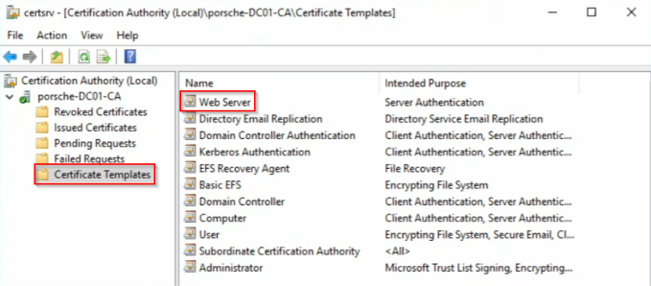First, we ensure that the Web Server template has been issued

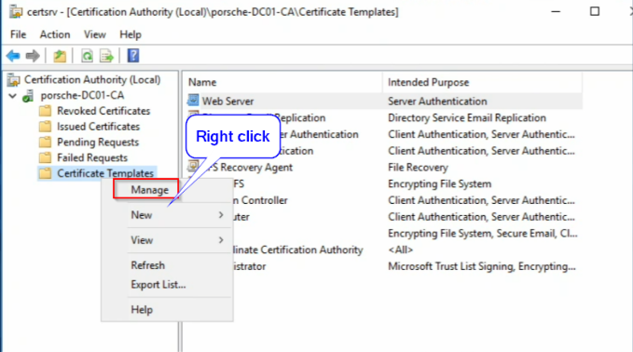Managing the Web Server template in order to give ADFS01 Read and Enroll permissions

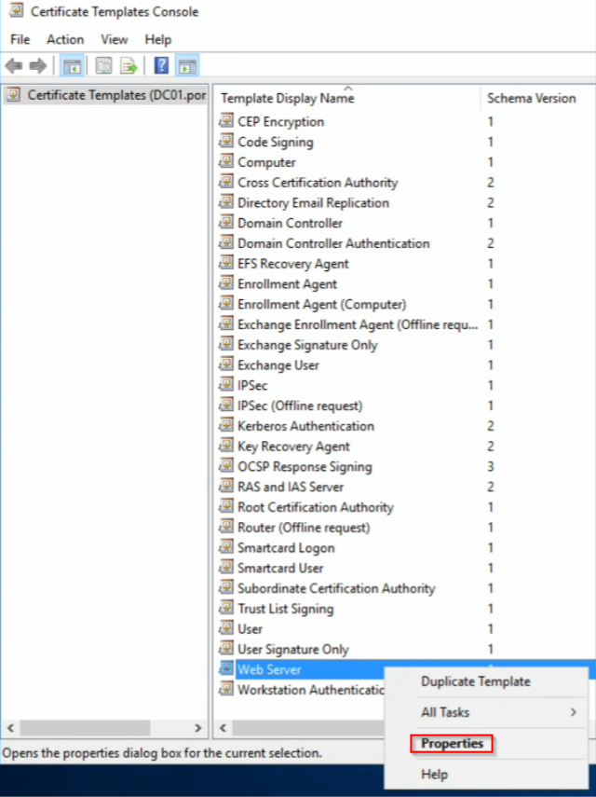

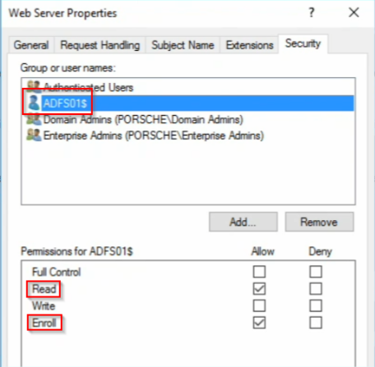

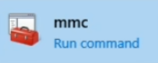Returning back to the ADFS01 server, pull the certificate to the personal folder: Run MMC

Add the "Certificate" snap-in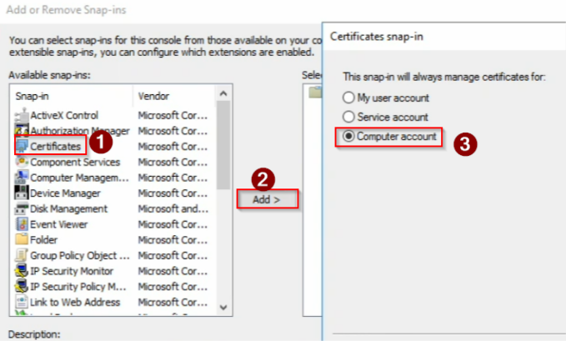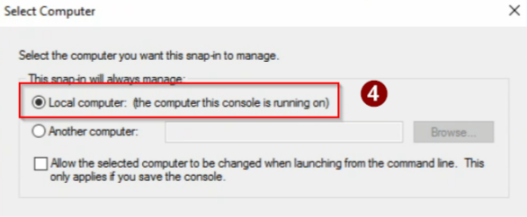

Troubleshoot alert

While attempting to request an SSL certificate for the AD FS federation service using the MMC Certificates snap-in on the AD FS server, the **Personal (Local Computer)** certificate store remained empty and no certificates were issued.

The Web Server certificate template was published on the Certificate Authority and the AD FS server had enrollment permissions, but the enrollment wizard did not successfully issue a certificate.

**Investigation & Root Cause**

The environment was using an **Enterprise Root CA**, which enforces certificate issuance based on **certificate templates**.

The initial certificate enrollment attempts did not properly include the required template attributes, which caused the CA to silently block issuance through the MMC wizard.

When switching to command-line enrollment ( certreq ), the CA returned an explicit error indicating:

The request contained no certificate template information.

This confirmed that the CA was rejecting requests that did not explicitly reference an approved template.

**Resolution**

To comply with Enterprise CA policy enforcement:

1. A new certificate request file ( request.inf ) was created on the AD FS server 2. The request explicitly specified the **Web Server** certificate template

3. The certificate request was resubmitted using certreq

This successfully issued the SSL certificate and installed it into the **Personal (Local Computer)** certificate store.

**Final Result**

SSL certificate for the AD FS federation service name ( fs.porsche.local ) successfully issued

Certificate appeared correctly in the Personal certificate store

Certificate included proper Subject and SAN values for HTTPS federation services AD FS was ready for secure HTTPS-based authentication and SSO

Imported certificate: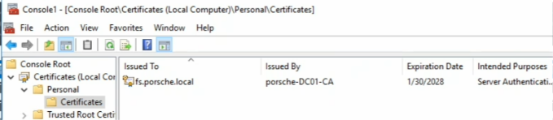

In summary:

Deployed an internal Active Directory Certificate Services (Enterprise Root CA) to support PKI requirements for identity services. Issued a Web Server SSL certificate for the AD FS federation endpoint ( fs.porsche.local ) using AD-integrated certificate templates, ensuring domain-wide trust and enabling secure HTTPS communications for federation and SSO workflows.

🚀 **Phase 4 — Install & ConfigureAD FS (Federation for Hybrid Identity + SSO)**

Installing the AD FS Role on ADFS01. AD FS provides claim-based federation services that authenticate users against AD and issue secure tokens for SSO to cloud and enterprise apps.

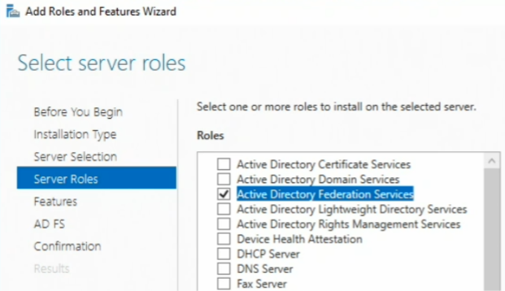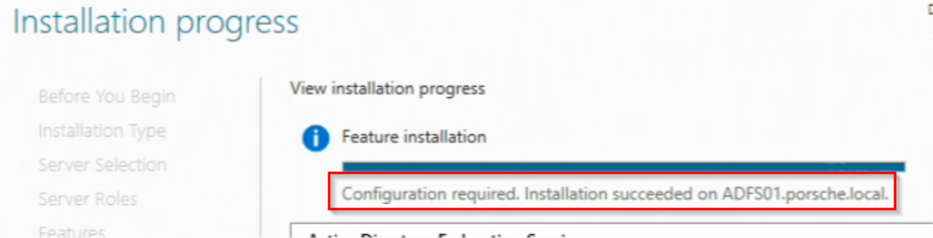

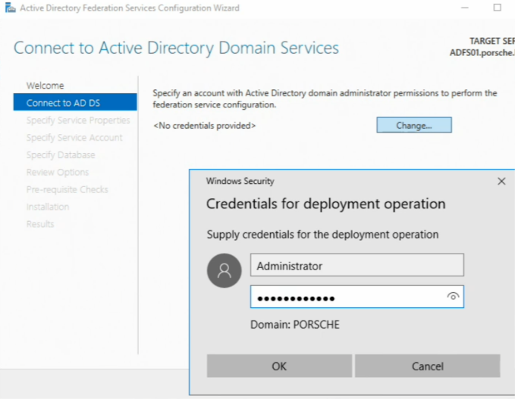AD FS Configuration:

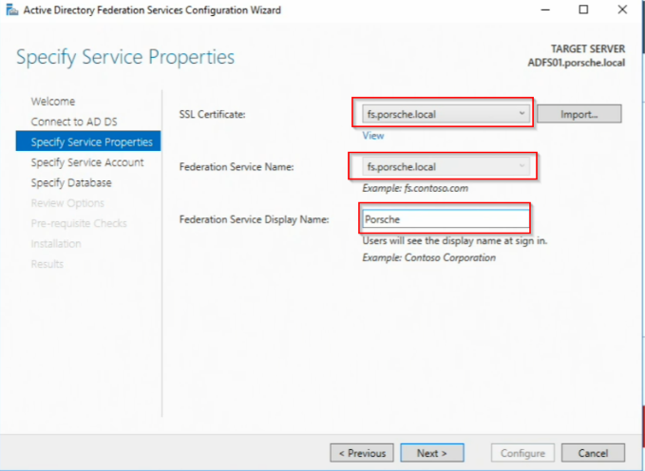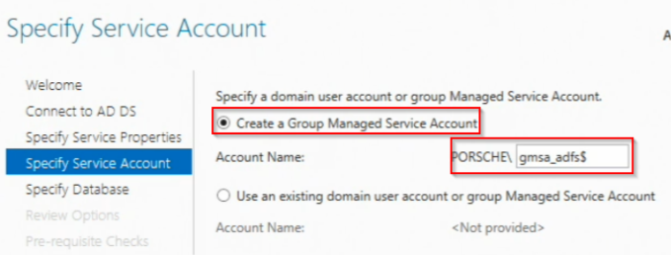

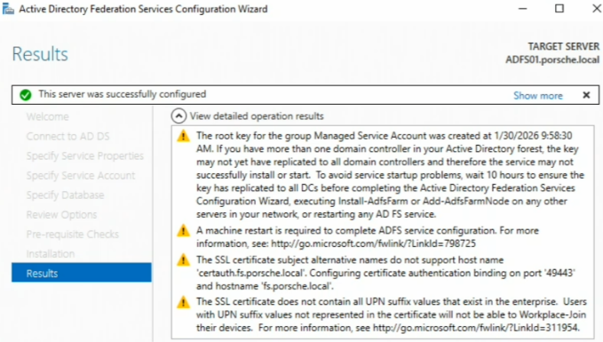

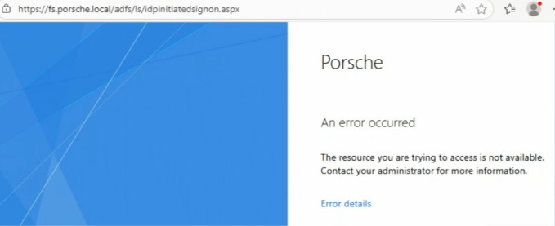In attempting to verify IdP services are up and running on the Windows 11 client, there's an error in finding the resource:

We will enable IdP-initiated sign on via PowerShell:

Set-AdfsProperties -EnableIdPInitiatedSignonPage $true Restart-Service adfssrv

IdP has now been initiated: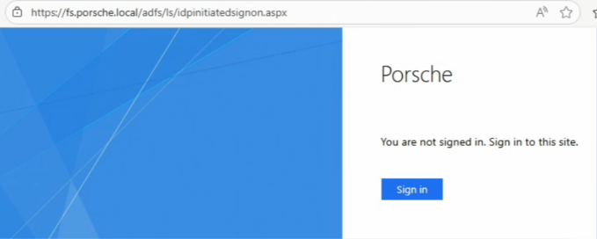

**Note**: IdP-initiated sign on is disabled by default and managed via PowerShell for security hardening.

🌐 **Phase 5 —AzureAD Connect (Hybrid Sync + Federation)**

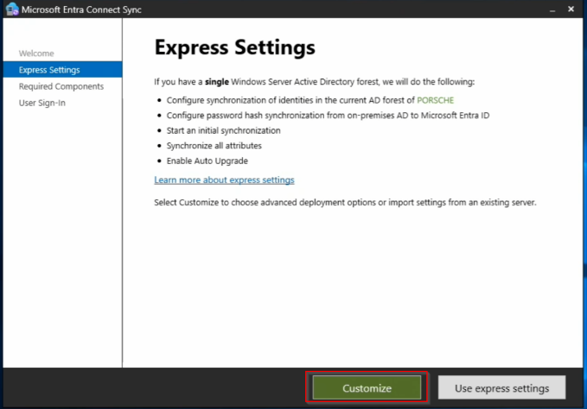Now working within our AADCONNECT01 server, we will download Azure AD connect

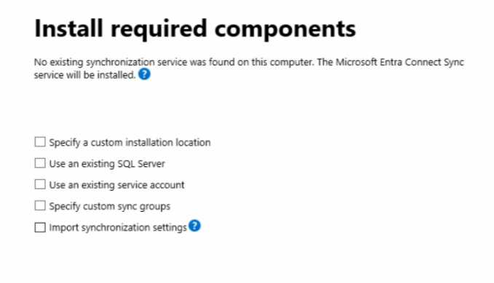

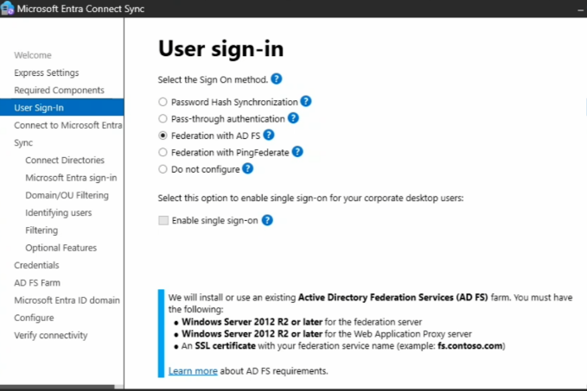Federation allows Entra ID to redirect authentication requests to AD FS, keeping credentials on-prem while enabling cloud access.

Connect to Active Directory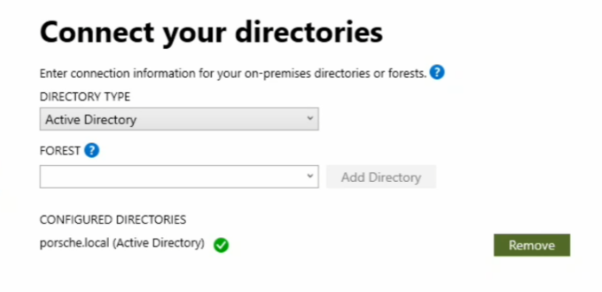

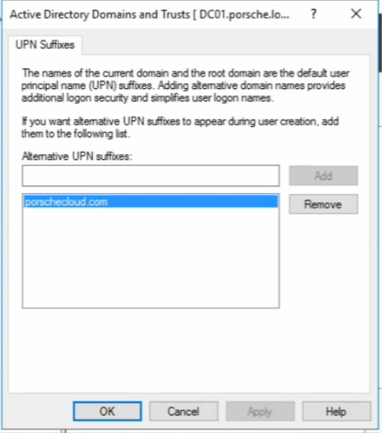**NOTE**: We will need to add a UPN under Active Directory Domains and Trusts in order for Entra ID to be able to federate sign-ons

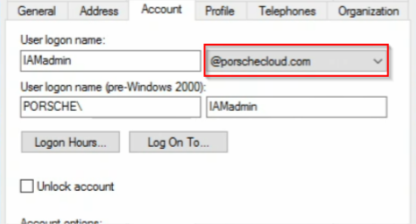Additionally, we must change the domain for our users:

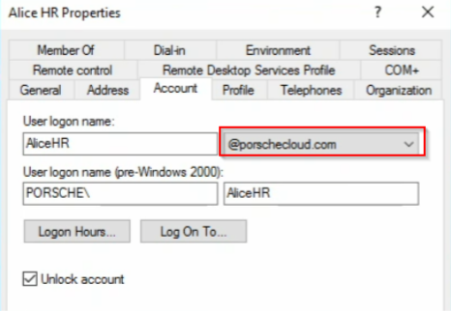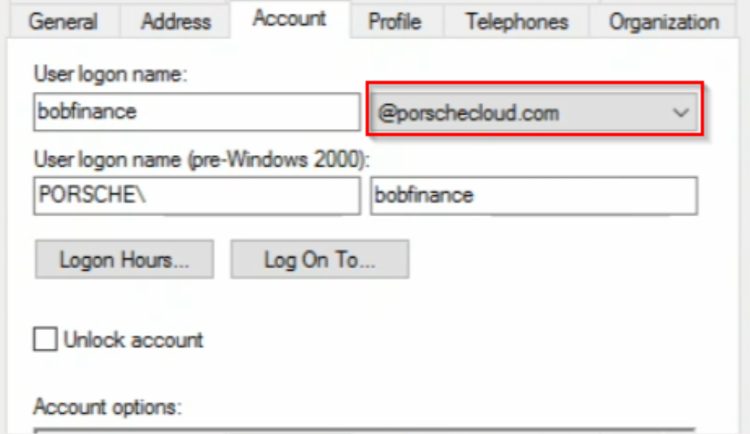

The custom domain name must be added to Entra ID as well: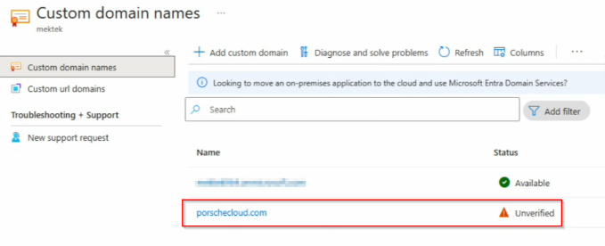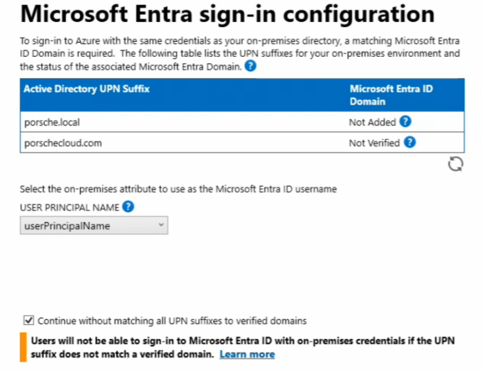

We can still continue to setup federation, sync to Entra ID and establish AD FS trust. If this were a production environment, we'd need to verify the domain

**Domain & OU Filtering (Scoped Sync)**

Instead of syncing our entire Active Directory (bad practice), we will only be syncing:

Users we want in Entra ID Groups used for access control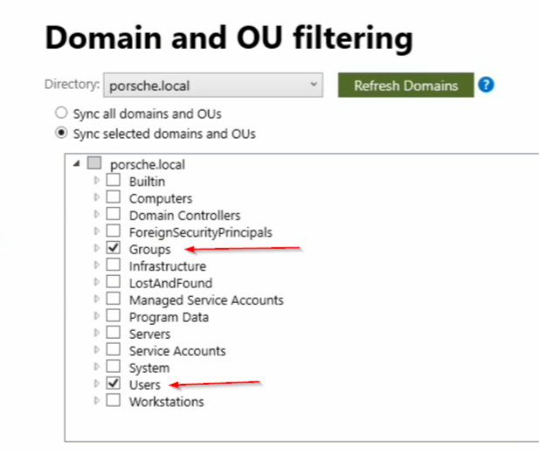

**Optional Features Enabled**

These are two of our most important features which highlight the hybrid setup.

Password writeback: enables users to reset password in Entra ID (SSPR) and have them written back to on-prem AD

Password hash synchronization (PHS): in a real environment, Microsoft recommends keeping PHS as a backup authentication method in case AD FS is down. This improves availability and disaster recovery.

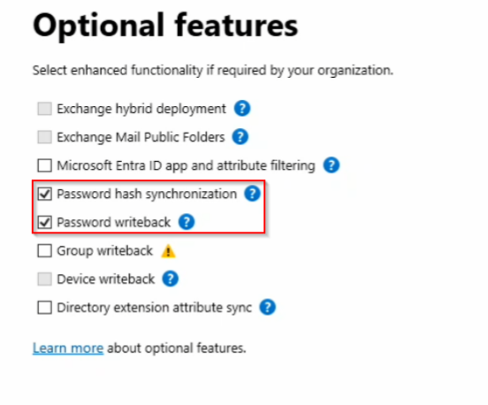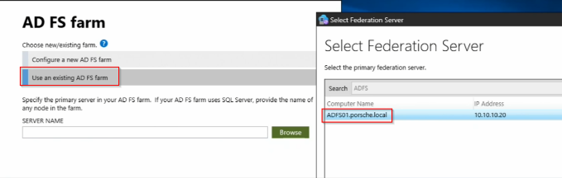

**AD FS Farm**

Linking Entra ID Connect to an existing AD FS farm allows Entra ID to establish federation trust with the on-prem identity provider without recreating or modifying federation infrastructure

**Note**: at this point I do not have a custom domain that I can verify in order configure federation services. I will be pivoting to Pass-through Authentication (PTA)

Pass-through Authentication allows cloud authentication requests to be securely validated against on-prem AD in real time without storing passwords in the cloud.

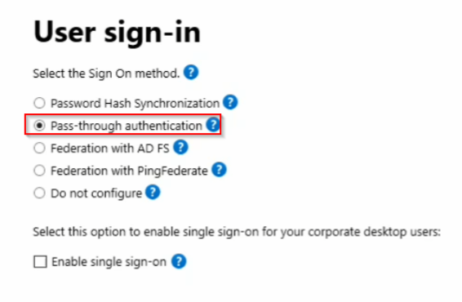

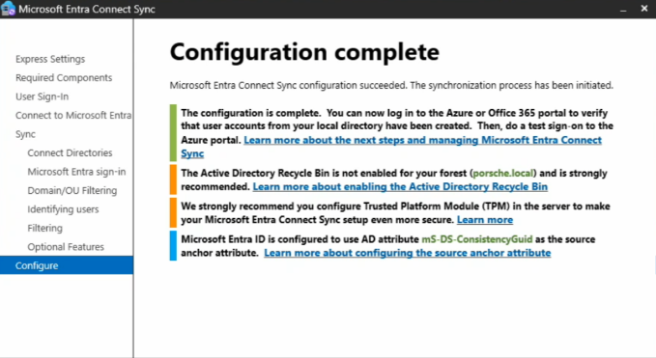Following the previous steps, configuration is completed:

Verifying hybrid sync in Entra Admin Center: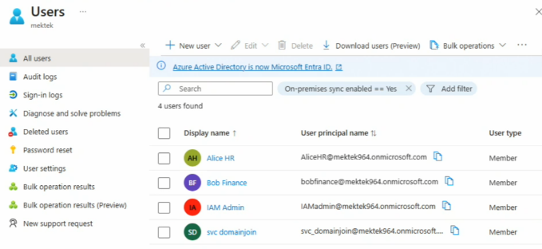

**Note:** ensure that the UPN suffix on-prem matches the Entra ID domain that you're using.

**Recap**

✔ **Hybrid Identity Architecture**

Synced on-prem AD users to Entra ID using Entra Connect Sync Scoped synchronization with OU filtering

✔ **Real-Time Authentication**

Implemented Pass-through Authentication (PTA) Validated live cloud sign-in using on-prem credentials

✔ **Lifecycle Integration**

Enabled password writeback for SSPR scenarios

✔ **Identity Alignment**

Configured alternate UPN suffixes for hybrid authentication